



Bear Nation Weekly Bulletin

Feb 14/25 Bulletin #22

|  |  |
| --- | --- |
| **Monday**  Feb 17 | Family Day – No School |
| **Tuesday**  Feb 18 | * Literacy in Motion will be on site for one-on-one reading support. * Sewing Club * Recorder Club @ Lunch for grades 4-6 |
| **Wednesday**  Feb 19 | * Literacy in Motion will be on site for one-on-one reading support. * Sewing Club * Merlin here in the AM * PAC Craft @ Lunch |
| **Thursday**  Feb 20 | * Fraser House here @ 1pm * Recorder Club @ Lunch for grades 4-6 |
| **Friday**  Feb 21 | * Gr 4-6 intramurals at lunch |

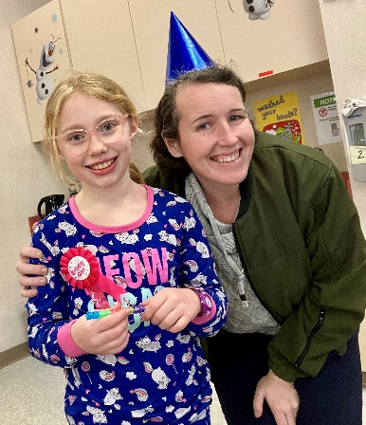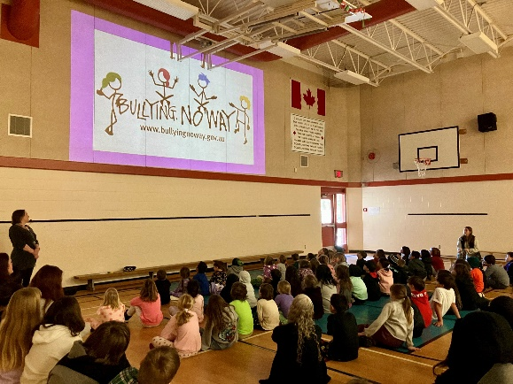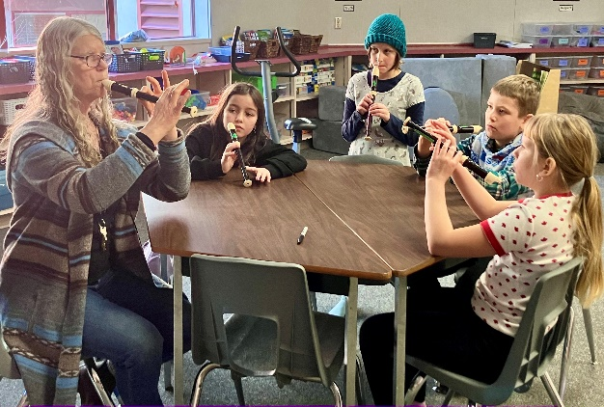

**A Special Thanks**

**We would like to say a special thank you to all our volunteers for helping and supporting our pizza lunch, reading and sewing club, and volleyball. Everyone has been enjoying the activities. We also want to thank the community for your understanding and patience during our power outage on Tuesday.**

Deroche Elementary School Phone: 604-826-2360 Fax: 604-826-7138

10340 North Deroche Rd, Deroche, BC V0M 1G0 Website: https://deroche.mpsd.ca

Dates To Remember

|  |  |
| --- | --- |
|  |  |
| Feb 17  Feb 26  Feb 28 | Family Day - No School  Pink Shirt Day/Hot Dog Lunch/Community Stroll  Parent teacher conferences |
|  | Crazy Hair Day |
| March 5  March 11  March 12 | Cultural Day  Pajama Day  **Reptile Guy 9-12**  Ready Set Learn 9-945  Wear Green |
| March 14  March 17  March 31  April 8  April 11  April 17  April 18  April 21 | Non-Instructional Day  Start of Spring Break  School Reopens after Spring Break  Pajama Day  Non-Instructional ½ Day  Curling Event in the gym  Good Friday – No School  Easter Monday – No School |



**Open Invitation**

We would like to extend an open invitation to any family members that would like to attend our assemblies! Every Monday at 8:45am in the gym. Hope to see you there.

**Parent Teacher Conferences**

Parent Teacher conferences are coming up on Feb 28. Teachers will be sending out digital invites for parents to sign up, please keep an eye on your email.

**Recorder Club**

Recorder Club has started! This will be held Tuesdays & Thursdays @ lunch for grades 4-6.

**Valentines Gift Basket Draw**

The sewing club will be holding a Valentines Fundraiser. There will be three Valentines themed gift baskets up for draw. All proceeds will be used to purchase some much-needed parts for our sewing machines. Draw date: Feb 26/25. Tickets will be sent home, and available at the office.

**Volleyball Practices**

Volleyball season has begun. Practices will continue Mondays @ lunch as the after school practices on Wednesdays have come to an end.

**Reptile Guy March 12/25**

We are still in need of about 5 volunteers who are comfortable holding the animals. If you are interested, PLEASE come into the office to fill out the volunteer form and go online to complete the CRC form at <https://justice.gov.bc.ca/screening/crrpa/org-access> - access codes are available at the office.

**Save The Date – Pink Shirt Day**

Save the date! Feb 26 is Pink Shirt Day and we will be having a hot dog lunch, followed by a community stroll. Family members are encouraged to join in!

**Reminder**

If you are taking your child home early, please remember to sign them out at the office. Child safety is our top priority.

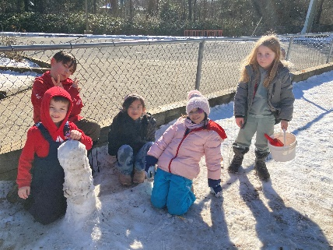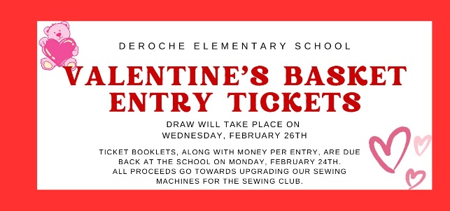

**FEB 26, 2025**